St. Louis Public Schools

TECHNOLOGY USAGE District Network/Internet

Access and Assignment of e-mail Account

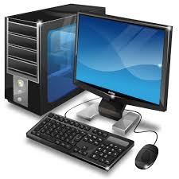

**Parents/Guardians,**

**Please review the below with your child (ren):**

*Student Agreement

I have read the St. Louis Public School District Technology Usage Policy, administrative regulations and guidelines and agree to abide by their provisions:

I understand that violation of these provisions may result in disciplinary actions taken against me, including but not limited to suspension of revocation of my access to district technology, and suspension or expulsion from school.

I understand that my use of the District’s technology is not private and that the school district may monitor my use of district technology, including but not limited to accessing browser logs, e-mail logs, and any other history of use.

I consent to teacher monitoring of my activities on the District network or the internet. I consent to district interception of or access to all communications I send received or store using the District’s technology resources, pursuant to state and federal law.

*Student Signature

Parent/Guardian Printed Name:

Home Address

Home# Cell#

Parent/Guardian Signature Date